The Long Road Up - Part 2
Gary Wise
Disclaimer: the views expressed in this article are those of Gary Wise.

Saturday, September 30th
We awakened early enough that we'd be able to grab some breakfast and take our time getting to the sight. Thankfully, Scott's decision to take a quarter of a sleeping pill had worked a miracle, allowing him seven hours of sound sleep without enough drowsiness to notice. I, also getting a decent night's sleep, awoke not only feeling a little more awake, but also feeling a strange confidence. One thing I would always do before the match is psyche myself up, much like a football team would before the big game. In essence, I got myself into a zone, making me a little more focused on the task at hand, and hopefully, make myself a little bit more intimidating with the confidence this communicates to opponents. Having had a night's sleep to dwell on the day before, I guess the fact I'd gone 6-0 against some pretty tough players gave me a certain quiet confidence that really wouldn't be shaken for the rest of the tournament.
We again went and grabbed some coffee and breakfast before heading to the tournament area. Not much of consequence happened before the first draft, so after some last minute strategy discussion and pumping one another up, we headed to the feature match area.

Draft 1: The Fix. Justin Gary (a), Bob Maher (b) and Dave Williams (c). Eventual finish: 25th
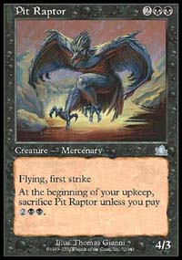
Well, the draft didn't go exactly according to plan. We kick off, mostly due to the misconception that receiving (getting picks 3-5 in pack 1) allows you to be reactive. I think the reality is that with only three early picks for the kicking team in the first few packs, kicking off is actually the more reactive strategy, as those first three picks can be considered expendable.
The big problem during the draft was Bob's outmaneuvering us with his seat. Bob started out WU and we quickly maneuvered black into my seat. Our general strategy was to try to get black against WU because of the incredible advantage of Fen Stalker and Rathi Intimidator in that match up. When Bob saw that I was going BW, he switched colors, moving into UB, giving himself a very strong deck against my rebels. Another problem was that with only one draft together between GP Pittsburgh and this round, communications were difficult, culminating in Mikes taking a Coastal Hornclaw for his BU deck instead of the Pit Raptor which might as well have been game for my deck. Bob got the Raptor to go with a ton of other flyers and Withdraw and their team started dancing in their seats, even going so far as to start making broom-sweeping motions in our general direction. I ended up with a mediocre rebel engine, Bog Smuggler, 2 Troubled Healers (which, while still great, are weaker against UB than any other color combo except UW) and relatively little kill in a deck where I was going to have to get fast draws to beat the Bomber.

It was at this point that Jeff Donais came over to the table with a surprise...
Mike's match looked like a good one for us with his UB evasion and kill combining nicely with the Crooked Scales he opened to give him an advantage over Williams' rebel deck. Scott's match didn't look too good, with his RG beatdown deck looking across the table at Justin's BG deck, which included multiple Derms, regenerators and Seal of Dooms.
When Scott and I got to the table, we started talking about how we had to keep focus despite the odds. Mike arrived with the statement "I thought that went rather well!" Managing a weak laugh, I told Mike that I thought he was completely nuts. We had a quick discussion about Mike listening to us a little more during the draft (Mike had done the most testing, so he was more or less running the draft. I think having one person organize things is the smartest approach, as long as the others are able to contradict that person when necessary). It was at this point that Jeff Donais came over to the table with a surprise...
Nail polish aside | The night before, with his team eliminated, Matt Vienneau informed me of his nefarious plot to dominate Pro Tour drafting through superior communication devices. While our team had a number of signals set up, we hadn't had many opportunities to get used to them, so, with draft day looming and the miscommunications of the first draft, I decided to use Matt's idea, which was to coat one each of his fingernails with polish of the five colors of Magic. This would allow for the quicker communication of information like 'what colors am I', 'are you blue' or 'he is red-green'.  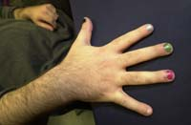  So I donned the polish, painting the nails on my right hand alphabetically, leaving the last one unpainted for white. As I was a drama major for a couple of years, the idea of wearing make up isn't that big a deal to me as I'd done a lot of stage work. This said, for the rest of the Pro Tour, it seemed to be all too big a deal. Pictures of my hand were taken and questions with regards to my sexual preferences were asked. Interestingly, the only mention of the polish at the end of the tourney was a picture with the heading 'Gary Wise, sans (without) nail polish'. This may just be because I'm a major nail biter whose hands are a bit choppy as a result. Regardless, I don't think it was that big a deal, and if your team needs to improve its communications, I'd suggest this strategy.
So with our decks built, we headed back over to the feature match, where we find our opponents sitting with confident looks on their faces.

Round 7: The Fix
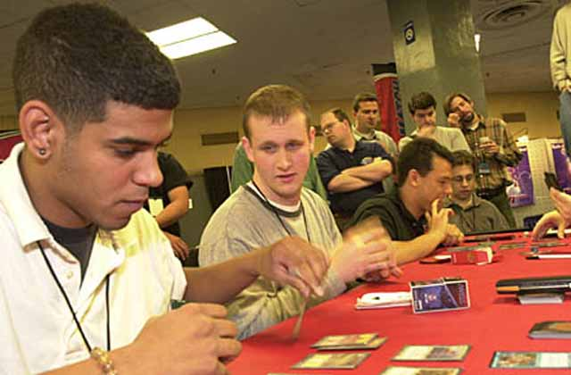
Well, despite the fact that he never got to cast the Scales, Mike was able to sweep Dave thanks to a timely Massacre in Game 1 and Dave's mana flood in game two. Justin swept Scott thanks to a really strong use of Woodripper (killing Mercadian Atlas and Crenellated Wall), a 3-for-1 Seal of Doom in Game 1, and Justin's Turn-2-Trellis, Turn-3-Derm, Turn-4-Thresher Beast in game two.

Turian would have felt good about his chances at the Alamo.
In my match, Game 1 actually looked good for about four turns. Coming out with a third-turn Bog Smuggler and fourth-turn Rathi Fiend, I started playing the game as a race to twenty, and screw control, with Soul Strings in hand to regrow the Fiend. Bob got down the Raptor and a Zeppelin and started racing, with his 7 points per turn being a lot better than my two. I lost hard.
Game 2 saw Bob mulligan twice while I got the rebel engine going quickly. Eventually building up a five to two creature advantage with Troubled Healer, I was able to continually swarm until Bob had to scoop.
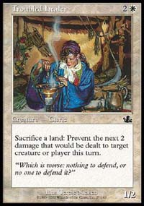
In Game 3, I started fast with a Turn-2 Falcon and Turn-3 Seal of Doom, but Bob had once again drawn the Raptor. As Bob started racing, I started summoning as many creatures as possible and mounted a counter-offense. With four of Bob's lands tied up, I was able to get enough on the table that when I finally cast the Troubled Healer I'd been holding back for the right moment, Bob was forced to go on the defensive. With about eight lands in play, I was able to start throwing my creatures at Bob, with the Raptor costing me a couple of lands per turn. With Bob's eight lands being tied up by the Raptor and his constant recasting of Stormwatch Eagle, I cast Stronghold Discipline, which, with Bob at two, forced him to return his Eagle to hand. When he couldn't cast it the next turn, the game ended, with Bob then being told by members of BIG that a certain mistake had cost him the game.
5-0-2
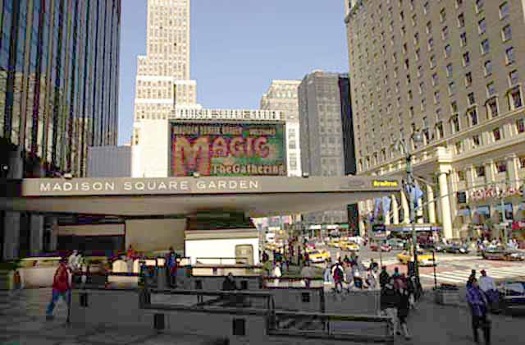
At this point, I was asked to go with Bob, Jon Finkel and Germany's Min Shin to do some promotional photos. Heading outside with the oversized $60000 check and the photographer, we held up the 2nd draft by ten minutes while waiting for the Madison Square Garden advertisement board to flash the Magic sign up so we could get it in the picture.
As we sat watching the passerby stare at us in confusion, I had a quick peek at the check and started to dare to dream. It looked like the three pre-tourney favorites are a long shot for top 4, meaning that we had to be moving up in the realm of favorites ourselves. With the other Pittsburgh team, Car Acrobatic Team, dominating, it looked like Mike, Cuneo and the rest of their team has this format pretty much figured out. For that brief moment, I accepted my own dare to dream.

Draft 2: Goblin Gate Arhaus. Jorn Hajek (a), Ben Christianson (b), Mike Stehr (c). Eventual finish: 18th
With four consecutive rounds against PT point qualifying teams, I have to admit that when I saw which team we were playing, I was a bit relieved. With Ben playing at his first Pro Tour, Mike at his second and Jorn at his third, this team, while obviously performing well, didn't have a lot of experience, and with a lot more money and prestige on the line then they may have counted on, we were hoping the nervousness was setting in.

It was like watching someone try in vain to protect a small child from an oncoming bus in slow motion...
While the last draft didn't look like it had gone very well, this one looked great. Not only did we open great boosters, but they also have some communication problems. This peaked when Jorn randomly took the only mildly playable blue or white card, Rootwater Commando (against the non-blue deck) when Stehr obviously wanted to splash it against Turian's UR deck. It was like watching someone try in vain to protect a small child from an oncoming bus in slow motion. 'NOOOOOOOOOOOOOOOOO'.
My deck was actually pretty beastly. I had a RW deck being played against GW, and I drafted four Flowstone Walls, Ancient Hydra, Parallax Wave, Rupture, some good kill and nice creatures. Ben's deck was a not-so-fat GW deck that needed to draw Troubled Healer to have a chance at the win. With this being his first PT, Ben couldn't be feeling too good about his chances.

Round 8: Goblin Gate Arhaus
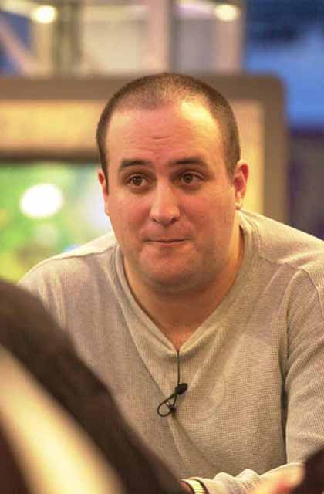
Well, Game 1, things went pretty much according to plan. I got down some fast beatdown, did some attacking, cleared the table with Hydra and P. Wave and got the duel win. Game 2 didn't go quite so well. With Turian losing to a mistake involving his Ensnare and his opponent's Chimeric Idol, I knew I really needed to finish this one off, but when I went for the win with the Wave, which, among others, took out a Defender en-Vec with no counters (an aggressive error in hindsight. I probably could have waited a turn, but I was going for the win), he had the Disenchant waiting and all of a sudden his Healer, Pious Warrior and fresh Defender came back into play, costing me some card advantage. Slowly but surely, he started locking down the table with the Healer, Spidersilk Armor and a bevy of creatures, so desperate times called for desperate measures.

I called him on it, telling him "don't you dare lie."
With three Flowstone Walls and a Lightning Hounds in play and Ben at 9, I pumped a Wall to 5/1 and cast Rupture, figuring I could destroy a bunch of his twelve or so lands in the process. Ben reminded me that the spell had not yet resolved and the target had not yet been chosen. I brought the Wall back into play and Ben cast Wild Might, choosing to pay the 2 mana to keep things reasonable (I wouldn't have paid). I told him that Wild Might resolved and that I'm ready to resolve Rupture. Ben said "okay." As I placed Rupture and the 6/2 Wall to the graveyard, I turn to Mike Feuell and said "Troubled Healer can't be activated once Rupture has been cleared to resolve, right?" At this point, Ben begab arguing that he had indeed not said it was ok to let the Rupture resolve when it was very clear that he had. Whether this was a miscommunication on his part or a misunderstanding of the rules is uncertain, but what was clear was that when I said that he had said okay, he blatantly lied, saying he hadn't. Of course, with a large crowd around us, I start to get pretty upset. He'd screwed up and was now trying to lie his way out of it and I called him on it, telling him "don't you dare lie." His response was to say that it is I who was lying.
Now, there are a lot of things I can accept. If someone wants to call me a loud, brash, and conceited, they can feel free to do so. Say it to my face and tell me you have a problem with me and I'll give you my respect, because at least you've been honest and had the respect to tell me how you really feel. One thing though, that I will not put up with is being called a liar. Before I was ever on the Pro Tour, there were times where I was far less than honest, and having "reformed," I work very hard to maintain what I think is a well-earned perception that I am an honest person. My work as a reporter relies upon my credibility, and that means that so too does my place in this game. I started tearing into Ben, saying that I not only maintain that I'm honest, but that there were dozens of people in the room who would vouch for that. Ben retaliated saying that there was no way that I, as an American, would be allowed to curry to public favor. Now, many of you may think I'm an American, but I'm not. I'm a Canadian. I was born in Canada and live in Canada and let Ben know this in no uncertain terms. I let him know that I was insulted by his calling me an American, not because of what I think about the USA so much as the fact is I'm not. There's nothing wrong with England, but call a Scotsman English and they won't be too pleased with you. In the end, an "objective spectator" (I don't know who) approached Dan Gray and told him that my story is correct, and Dan ruled this way. The table was wiped clear of creatures, Ben went to three life, and the next turn I cast an Ancient Hydra doing three points for the win. I extended my hand telling him it's his choice, and he shakes it. With Scott winning his match, we won another close one.
6-0-2
For the second round in a row, I held up the Tour, this time for an interview with Organized Play. It seems strange to me that I'm doing all of this promotional stuff while Mike and Scott sit and wait for me, but I wasn't complaining. Finally getting the interview done, it turns out things have only been held up for about five minutes, so we regroup and got ready to play for first place.

Draft 3: Car Acrobatic Team. Andrew Johnson (a), Aaron Forsythe (b) and Andrew Cuneo (c). Eventual finish: 2nd
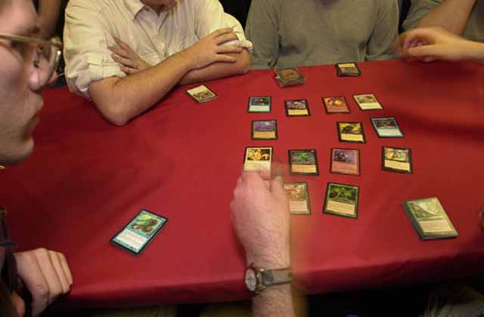
Well, you have to give the Pittsburgh crew all the credit in the world. Turian and CAT did 3-4 drafts a week for months and figured out how best to draft this format, despite the fact that the equation went against the conventional wisdom that said white should be in the leftmost seat. According to Mike, in practice he was going about 50-50 against CAT but that he felt that with the caliber of play Scott and I were capable of producing, he felt this would be a good match up for us. Of course, Turian would have felt good about his chances at the Alamo.
The draft worked out okay. Scott drafted a White/Black deck against Andy Johnson's WRB deck. The key to the match up seemed to be that both players had Troubled Healer. CAT made a crucial mistake, letting Scott get a Bog Elemental against a deck whose creatures were almost all white. Mike and Andrew's matchup looked close, with Andrew potentially having the advantage due to a number of large fliers.
My deck was pretty strong, a GR beatdown with a couple of red Seals, a pair of Laccolith Warriors and a Derm, going against Aaron's GB deck that had only three cards I feared: Seal of Doom, Rathi Assassin and Cateran Enforcer. I felt strong enough at this point, with an 8-0 streak going from the start of the tourney, that all my partners had to do was win one match between them, because I wouldn't be losing. We headed to the tables...

Round 9: Car Acrobatic Team
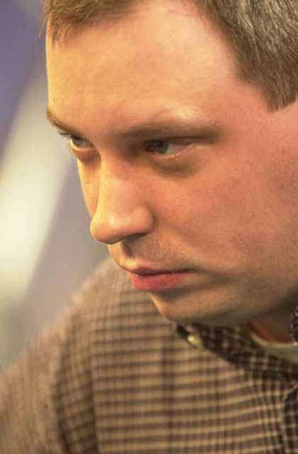
Aaron Forsythe
...And wow did I misjudge this matchup. Game 1 I started out decently with Turn-three and -four creatures, but after starting out with four lands in hand, I kept drawing more and more. Couple this with the fact that Aaron drew not only the key Seal of Doom but the Enforcer with which to finish me off, and you have an unwinnable game.
Game 2 saw me again come quickly out of the gate, but I made a questionable play, using a Seal of Fire to remove an early blocker. This came back to haunt me as Aaron first played a Seal of Strength, then the Rathi Assassin. I quickly stopped attacking as Aaron gained more board control with each turn as I desperately hoped to find some way of killing the Mercenary, but the one Rhystic Lightning I drew wasn't up to the task because of the Seal. If I'd kept my Seal of Fire, I might have been able to win the game, but Aaron played better then I did and got the win he deserved.

So ten minutes into the match, I'm sitting there beaten...
So ten minutes into the match, I'm sitting there beaten, my streak gone, knowing I'd let my team down. Mike wins his match leaving Scott and Andrew to duke it out. Scott took the first game pretty handily before losing a Game 2 he thought he had control of thanks to Andy's Flame Rift. Game 3 started with a lot of time left in the round, but as the world would find out the next day, these two are both capable of playing pretty slow and time became an issue, especially since both players had Troubled Healer in play. Finally, with the clock ticking, Scott drew into what, in this situation, was a total bomb. With Andy's side of the table sporting five white creatures, Scott played his 5/4, Protection from White Bog Elemental and started beating down for five a turn. Watching the match was excruciating because through it all, Scott was holding a Parallax Dementia, which I would have played on Andy's Troubled Healer a lot earlier in the game. Running out of land and time, Scott finally cast the Dementia on the Elemental and did enough damage that Andy didn't have the land to stop. Scott won the game, we won the match, and moved into sole possession of first place, by a point over Cat and BIG.
7-0-2

Draft 4: B.I.G. Brian Hacker (a), Gab Tsang (b), and Igor Frayman (c). Eventual finish: 7th
The week before New York, Brian Hacker came to Toronto for a little drafting and poker. With communications problems leading to BIG not participating in St Louis and Gab being stranded in Pittsburgh without a team, there was talk of possibly replacing Igor, if not for this year, then for next.
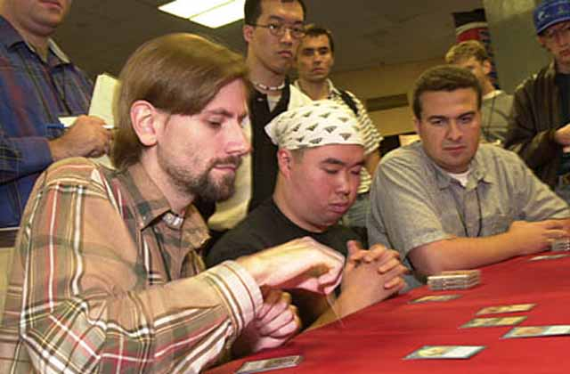
During the course of one such conversation, we got to talking about why it was that Brian was so dedicated to Igor (not that friends shouldn't be), with Igor's failing to show at the two Grand Prix showing a lack of commitment. Brian's contention was that with Igor's recent performances in Limited PTs being what they have been, Igor may well be the second best limited player on the planet (after Jon Finkel).
Now, Igor is a fine player, and I really believe that if he played as much Magic as the average Pro player, Brian might be right, but with Igor's time split between work and poker, he doesn't have the environmental knowledge others have, meaning that his game can be improved. Igor shows up for PT's having never drafted a set and makes the Top 32, reading the cards his opponents cast all the way, so one can only wonder what he'd be doing if he were to work on his game. Until he starts doing so, I'll have trouble putting him in the stratosphere that Brian does.
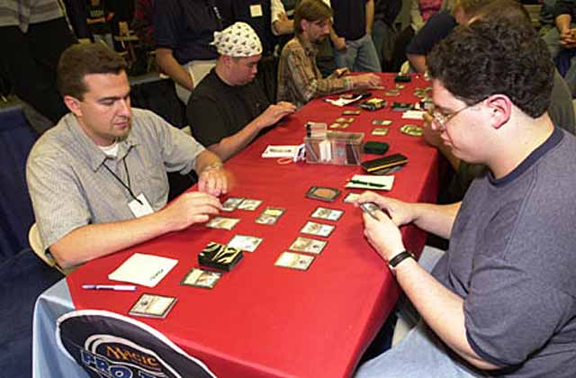
Who's the better drafter?
I started naming off players I felt might be better than Igor: Baby Huey Jensen...Kai Budde...Ben Rubin... Brian deflected each suggestion, saying Igor was obviously better. Finally, I named off Mike Turian. Brian stopped for a moment and said 'Turian's pretty good, but I'd rather have Igor.' Well now, that was going to come back to haunt him.
As we approach the table, I happened to mention the above conversation, and just how bad Hacker would look if not only Igor, but his team as well, were to go 0-2 against Turian for the tournament. Hacker, with the mischievous gleam he always seems to wear, told me not to worry about it.
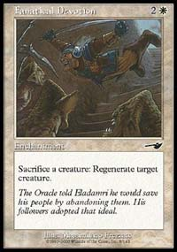
I started the draft in black, but it quickly dried up. Gab started in WG but with Brian in Green, eventually switched to WR. This left an abundance of green, leading me into GW, which is generally a decent matchup against WR, though both Gab's deck and mine were substandard.
The funniest part of the draft came when BIG let Scott get Arms Dealer and Squee out of one pack. They apparently hadn't noticed the combo sitting there, because Brian's eyes nearly left his skull when he sees what they passed to Scott. Fortunately for Brian, he was the fortunate recipient of three Blastoderms, giving his UG deck an advantage over Scott's RW. Turian seemed to have the advantage in a UB mirror match with Igor, so mine looked to be the rubber match. With our decks built (mine included a Fanatical Devotion, pretty good vs. Gab's Rupture, red kill and two Lesser Gargadons) we headed over to the feature match area with the match, the next day and thousands of dollars at stake.

Round 10: BIG
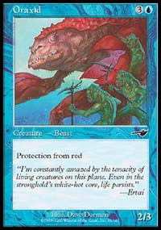
Blastoderms didn't bother Scott, but protection from red was a nightmare
Well, with the news that he was definitely the inferior player to Igor, Mike had no choice but to beat the Russian for the second time in the tournament, with his slightly faster deck breaking out of their double-manascrew in Game 3 in order to secure the victory. Scott had no trouble handling the Blastoderms, but Brian's two Oraxids put an effective stop to any possibility of an offense and carry him to the 2-0 victory, so it was me vs. Gab with Day 3 on the line.
Game 1 was probably the most frustrating I would play in the entire tournament. After playing a quick Defiant Falcon and Nightwind Glider, I got stuck at three mana and my frustration resulted in some really poor play. With my hand full of business spells, I kept my Falcon back, thinking so much about how I want a land so I could start searching that I wasn't using it to deal the damage it was capable of. Gab started attacking with his own Falcon after searching his rebels from his deck and I started going lower and lower on life. Finally, I drew some mana and started casting my spells, but the turn before I could get the win, Gab finally cast the Rupture he'd been holding in the hopes he wouldn't have to use it (for fear of damage prevention), finishing me off.
Game 2, fortunately, was the opposite. Orim's Cure gave me the early advantage, killing Gab's Fault Riders and the land that had been sacrificed to them. Also, Hunted Wumpus is an amazing card when your opponent has played their fourth or fifth land and said "go," as it usually means they don't have a creature in hand. It's also pretty good when it follows a Blastoderm, and if one's opponent doesn't draw into their only two big creatures. I rode the fatties to victory. Not content with a draw, I looked and saw that there were fifteen minutes on the clock. I did a very quick check of my sideboard and prepared for game three with the full knowledge that there was a lot at stake. I got a draw that saw me play Spidersilk Armor and Fanatical Devotion to protect my fatties. Gab did some early damage, but once again he has nothing when I played Hunted Wumpus and I started beating down. Gab slowed down a little with time running out and I asked the judges to keep an eye on it, knowing that the only thing stopping me from the win would either be a misplay or the clock. I was playing at a rapid enough rate that I mase a couple of technically horrible plays, but having a 6/7 creature with Devotion protection makes those plays excusable. One turn, Gab tried to take advantage of my hurried state of mind, emptying his hand in an attempt to kill the Wumpus, and when he dealt seven, I picked it up and almost put it in the graveyard. I stopped just short, realizing that I have a Trenching Steed that can be sacrificed to the Devotion, and I used it thusly. Two turns later, in the second extra turn, I won the game, and we the match.
8-0-2
A wave of relief washed over me with the realization we've just made the Top 4. We took a breather, discussed whether we should draw or play, and finally decided that while there was an outside chance that we might finish second instead of the desired first by drawing, it would save us the energy for the next day and the likelihood was that it wouldn't matter (final seeding is the tiebreaker used to determine who is third and who is fourth. If we were second and the first-place team were to lose their semi-final, losing our semi would mean we'd lose the thousand dollars that makes the difference between third and fourth).

Draft 5: Draften und Spielen. Patrick Mello (a), Christian Lührs (b) and Stephan Valkyser (c). Eventual finish: 4th.
While a draw wouldn't assure the Germans of a spot in the Top 4, it would make their chances pretty good, especially with us registering twice in their tiebreakers. We agree to the draw, asking Head Judge Dan Grey if we can draft anyways.
The draft went almost comically. While the Germans took it pretty seriously, we were too giddy about Sunday to do so, doing a little rare drafting and having a good time. Stephan questioned how we ever got this far. By the end of the draft, Christian and I both had great decks, with what would have been our match up coming down to how we drew. We shook hands with the Germans and wished them luck on the final standings.
8-0-3
We waited around for the end of the round so we could hear what position we were in and who we'd be playing. We ended up in first, meaning the least we could make would be $6k/head, leaving us in a pretty good mood. Scott suggested that we head back to the room, talk a little strategy and rest, but I had other things in mind.
The last time I was in NY, Mike Flores, John Shuler and the entire Dojo crew took me to a restaurant called Curriscaria Plata Forma, which specializes in Brazilian food. What I found out upon arriving is that, apparently, Brazilian is Portuguese for "a lot," because those two words best describe the experience. Throughout the evening, 15 waiters, each sporting yard-long skewers covered head to toe in flank steak, sirloin, prime rib and a dozen other meats swarm your table, quickly answering your every whim. Throw in about 15 appetizers, the greatest salad bar in the world and an awesome chocolate mousse and you have one of the best meals you'll ever have.
This all said, Curriscaria Plata Forma became an instant tradition, and Becky Hiebert and I had been planning on engaging in said tradition for some months now. So with Matt Vienneau, Dirk Baberowski and others in tow, we headed off for dinner. After a few wrong turns we finally found our way. So happens we bumped into a few "zebras" there, and a great time was had by all. Come midnight, just as the party was really getting started, I took my leave, knowing full well that while I'd be missing a good time, we were the favorites on day three, and that meant it was likely the biggest day of my Magic career. I got back to the hotel and slept a confident, calm sleep.

Sunday, October 1st

It's not often you awaken with this kind of day in front of you...
It's not often you awaken with this kind of day in front of you. When I arose, staring me in the face was what I would be playing for: $14000 (we were already assured of $6000 a piece), the title of Pro Tour Champion and a spot on the Masters series for the next year. With Worlds '99 and London (where I came 13th) falling off, coming into New York, I knew I wouldn't be making future Masters on PT points. The difference between winning and losing the semi-final was 2 points, with losing leaving me at 32, winning putting me at 34, likely the difference between playing in the Masters and playing in the Gateway. I was playing for a lot.
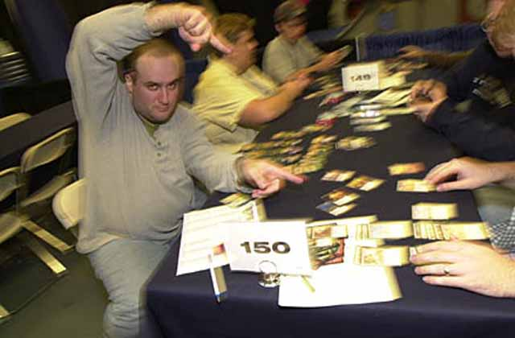
Despite all that was at stake, I was surprisingly relaxed. Since I'm not usually the relaxed type, it must be strange for others to watch me when being quiet and contemplative. I had a quick talk with Scott and Mike and then headed out, informing them that I'd see them at the sight. I headed down to Penn Station to get myself some nail polish remover, as WotC didn't want the decoration on TV, especially considering how poor a job I'd done of administering it. Unfortunately, the one place that had it wouldn't open until 8, by which time I had to be arrived for the players meeting, so I headed up to the Garden and asked that someone grab the remover for me later on.
When I got to the play area around 7:40, it was empty except for a few all-night drafters and a group of three kids and a mom who had just arrived from an eight-hour train ride. I went over and watched the kids play for a bit and gave them a few pointers. While for me this is just a way to pass some time, to the kids, getting help from this stranger was a pretty big deal. Sometimes it just feels good to help.
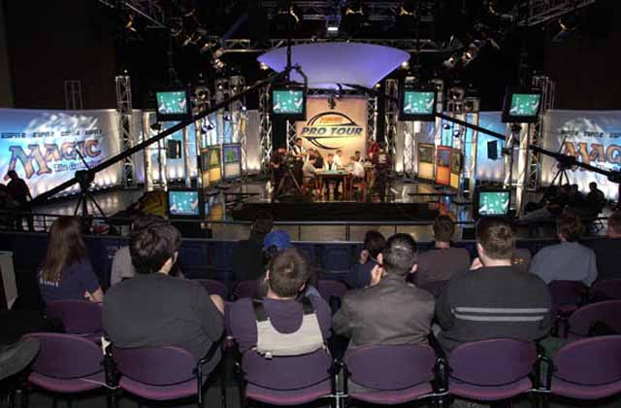
Finally, everyone started wandering in. First it was the WotC folks, then the Germans, Rolled Over Aces, CAT and, finally, Mike and Scott. The players meeting included our receiving commemorative baseball caps saying 'Top 4, PTNY', our going over the schedule and the decision to only have one of the semifinals under the lights. While Rosewater wouldn't tell us who would be playing under the lights, our semifinal had a combined seven Top 8s in singles competition, while theirs only had one, so it seemed likely that we'd be it. To be honest, these 'expectations' may just have been manufactured because I really wanted to play under the lights. Worlds '99 was the first PT where the quarterfinals were not on camera, and with my loss to Mark LePine, I never got the chance.
Finally, the decision is made that we'd be on stage. Mike, Scott and I sit down and have a couple of last moment words and get ready for the most important team draft of our lives.

Semi-final Draft: Draften und Spielen. Patrick Mello (a), Christian Lührs (b) and Stephan Valkyser (c). Eventual finish: 4th
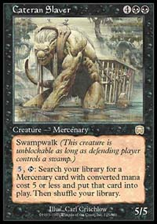
Well, all of our dreams of glory were short circuited by the draft, which promptly brought us back to earth. I started in WB, but in the fourth pack, Christian opened a Cateran Slaver, sending me running for the hills. The result of this was that we didn't have anyone drafting black, but this was made ok by their decision to split the black between Christian's UB deck and Patrick's BG deck. If they'd only had one black draft, we'd almost certainly have needed to win the other two matches.
So, with my ditching black, I focused on my white. I started off drafting a few rebels, then a few more rebels and then, for a change, I drafted some rebels. I ended up with 12 in total to go with a Parallax Wave and a crucial Flowstone Armor to go against the Bouncers and Witches on Christian's side of the table. Finally, with the option of going monowhite very much in mind, I opened up a Squirrel Wrangler and took it, deciding it would go very well with Snorting Gahr and Thrive as a splash.
Christian's deck was pretty strong too. Along with the Bouncer, Plague Witch and a Stronghold Biologist, he had a Squee to increase the spellshaper's power level. One mistake their team made during the draft was giving Patrick the Massacre that Lührs could have taken. If he had taken it, I'd almost think the match up was a good one for Christian.

Scott offered me a precautionary "don't play to the camera too much"
Unfortunately, almost everyone agreed that the draft went badly for us. Mike's RU deck included a Negotiations, but he was facing Power Matrix, Mageta and two Troubled Healers from Stephan. Scott's RG deck looked like it was out matched by Patrick's GB. Mike, usually confident, said "I like my deck, but he has some bombs," so the plan was that I beat Christian and one of my teammates would find a way to win their match.
After a lot of pampering, more makeup (for the lights) and some quick lessons on how to play for the camera, we headed down to the stage area. I spent two years as a Drama major performing under the lights, so nerves aren't really a problem for me, though I could see it affecting someone's concentration. Just before the match, Scott came over to me and offered a precautionary "don't play to the camera too much," but I'm pretty much in the zone and let him know it isn't a problem.

Semi-finals: Christian Lührs
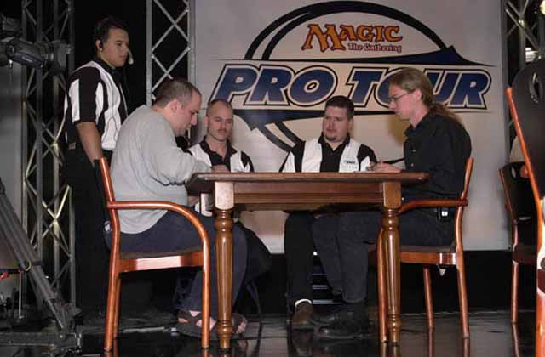
Game 1 was a thing of beauty. Playing first, I started the game out with a Plains, followed by another to go with Defiant Falcon on Turn 2. Christian played a second-turn Waterfront Bouncer, which I'm sure he'd have used on Turn 3 if not for my casting Ramosian Lieutenant and Ramosian Sergeant. It almost seemed like I was playing in the wrong PTNY, with my WG rebel deck making me look more and more like Ben Rubin.
Christian played a Plague Witch on Turn 3, which was met by my finding a Defiant Vanguard on Turn 4. At the end of Turn 5, I had one of the few decisions I'd have to make, deciding whether to search for a Lightbringer or Thermal Glider, eventually choosing the Glider as an attempt to continue pressuring Christian. Christian tapped four of his five lands on the next turn to cast a potentially dominant Stinging Barrier, but I had the answer in hand in the form of a sixth-turn Parallax Wave, which took out the Bouncer, Barrier and Christian's Coffin Puppets, allowing me a mass attack. The Plague Witch was able to remove a couple of my dorks, but not fast enough, with Christian's summoning sickness-inflicted Bouncer only being able to watch as a Diving Griffin did the last two points of damage.
Game 2, Christian and I play on camera. After waiting for a few minutes for the previous televised match to end, we get started, but Christian was discarding by turn three. I got out Squirrel Wrangler with Cho-Manno's Blessing in hand to protect it and it goes to work, making six Squirrel tokens. I attacked with all and could have pumped for the win on turn seven, but with the Cho back, I figure it would be better to play it safe. When I said 'no pumps' Christian's reaction was one of 'finish me off already', but when I show him the Cho after the game, he understood. Considering how bad his Game 2 draw was, Christian was a really good sport.
1-0
In the meantime, while on stage, I couldn't help but want to know how each match was proceeding. I constantly called to my teammates and asked how things are going. At one point, upon asking Scott, I got the answer "I'm about to take a big gamble" and then hear "Yes!" letting me know the gamble paid off. Later in the match, Scott informed us he was about to take another gamble, but this time it didn't work out, and Scott lost 2-1 to Patrick
1-1

So it all came down to the Potato...
So it all came down to the Potato. Playing against Stephan's god deck, Mike managed to win Game 1 before losing Game 2. As I watched Game 3, I told Christian what was going on as each sequence of events unfolded. Eventually he asked me not to, suggesting that maybe the nerves were getting to him a little more than he had let on. Stephan mulliganed game three and lost some major card advantage on a well-timed Withdraw by Mike, leaving the Potato "up three cards." Eventually, the table saw the Healer and a Panacea on Stephan's side and a large swarm of creatures on Mike's. Mike even had the Rethink for Mageta and a Mogg Salvage for the Matrix, so the game looked locked down. Finally, Mike made the last major assault and Stephan extended his hand.
2-1
With the win, I jumped up and slapped the Potato on the back. We'd just won $4000 a head, not to mention my having just qualified for Masters Series: Chicago. We went and had a little lunch after finding out that we'd be playing Car Acrobatic Team in the Finals. Before the semifinals started, we'd offered them a $2000 split if we played in the finals. Aaron seemed interested, but apparently AndyJ had no interest, so we'd be playing for all the marbles. This wasn't a big problem for us, as we'd offered the split more out of friendship than financial stability.

Finals Draft: Car Acrobatic Team. Andrew Johnson (a), Aaron Forsythe (b) and Andrew Cuneo (c). Eventual finish: 2nd
As badly as the semifinal draft had gone, all memories of it were eclipsed by the success we had this time around. I opened the first pack and saw a Wave of Reckoning, a perfect fit for our draft strategy. Mike took Gush over some superior black cards, establishing himself in blue as CAT knew he would anyway, and allowing them to choose colors and us to respond. Scott eventually got into white and mine dried up, so I start in black, the plan being to make white a splash.
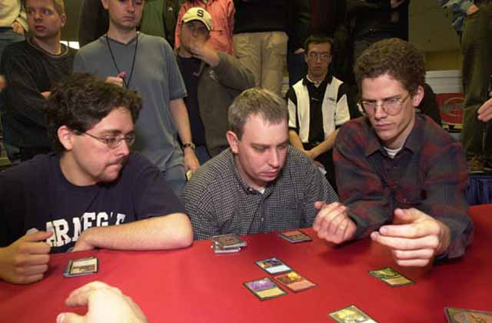
What we didn't know was that the packs were begging me to go black. After getting a relatively late Delraich, I got a Sever Soul and a Cateran Kidnapper, as well as a Lunge in the third or fourth pack. With Cuneo being the only other black player at the table, I had four first-shots at black cards in Nemesis, turning my deck into a powerhouse. The Kidnappers were joined by an Intimidator and a Rathi Fiend, with around six other Mercs to search for. I also happened into Volrath and the Ascendant Evincar, not to mention a Flameshot and three Rhystic Syphons in Prophecy. In short, in the match I couldn't afford to lose, there was little to no way I was going to lose.
Meanwhile, Scott's matchup looked pretty good too. With a solid GW deck with Blastoderm, Rebels and the like, Scott was feeling pretty confidant about his chances against AndyJ, with Andy's Troubled Healer being the one real problem spot. Turian's match up didn't look that great on paper, but Mike is the best player I know at drafting mirror matches, so he still had a chance. Cuneo's Rootwater Commandos and superior flyers were definitely a problem though.

I was feeling pretty good about my chances.
So both teams sit together and watch the Masters finals. Halfway through the match, Mike, Scott and I were asked to go do an interview with ESPN2, and do so. I stay relatively quiet, as I was starting to feel a little tired and trying to maintain some focus. The only outlandish thing I say came right at the end of the interview, when I said "I really like and respect Aaron Forsythe as a person and as a player, but I don't think there'll be much of him left at the table when I'm done with him." I was feeling pretty good about my chances.

The Finals: Aaron Forsythe
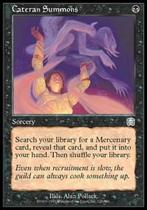
So it came down to this. Through the tournament, I was 10-1 in matches I'd actually played, and Aaron was the only one who had beaten me. A win meant $10000, a virtually assured spot in the Masters Series for the next year and, realistically, a place in Magic history. Aaron and I are both major buffs of baseball history, the type who pore over long-forgotten statistics that no one else in the world finds interesting, so I think he of all people understood the importance of that aspect of the match.
All through the draft, Aaron had been slumped in his chair, watching the monster I was now holding get built from the ground up. Now, his posture was different. He leans forward and stares me down. I, feeling pretty good, sat straight in my chair, cracking jokes and feeling pretty relaxed, all things considered. While I had wanted to leave the Wave of Reckoning in my sideboard, my teammates convinced me to play it along with the two red cards. In retrospect I think this was a mistake, with none of my creatures working well with it and a strong matchup suggesting that I should concentrate on keeping my mana solid. I side out the white after Game 1.
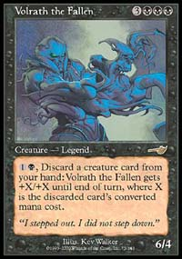
The first game started quickly enough, with me casting Cateran Summons for Rathi Intimidator. I played the Intimidator on Turn 3 and a Kidnapper on Turn 4 and am feeling very much in control. After Aaron cast a Keldon Berserker, I cast a Syphon, bringing the life totals to 25-11. After the Berserker takes the life I'd just gained, I mistakenly drop Volrath into play after accidentally tapping six lands. The game wasn't over yet though. Aaron played Treetop Bracers on the Berserker and started attacking with it for six a turn, and when I tried to trade my Kidnappers for Aaron's Vintara Elephant, he had the Wild Might ready, taking me all the way to one life. Finally, I held back the Intimidator, allowing me to search out a Misshapen Fiend as a chump-blocker, and when Aaron cast Monkey Cage before combat, I was forced to do the search in response. Aaron had to hold back his Berserker to chump-block Volrath, and the next turn, I rode in for the win in a great game that, of course, never made the camera.
Game 2, which makes it to film, is anti-climactic. The untrained eye of the ESPN viewer is going to think that I'm the best player on the planet, because the two games I've played on camera have seen bad mana draws by my opponents turn into routs for me. Aaron didn't cast anything until Turn 4 in this game, and even then it was a Spore Frog, not much of an answer to my third-turn Intimidator. The next two turns, I played Rathi Fiend and Cateran Kidnappers while attacking with the Intimidator, but Aaron killed both before they become active. I eventually cast a Belbe's Percher and the Misshapen Fiend as additional evasive beats, and when Aaron finally cast Living Terrain on his only Plains, I had the Sever Soul ready and waiting. Not much of a game.
1-0
With a couple of hours to kill on stage, Aaron and I shuffled our decks together and start playing. My mana draws were horrible (4c) and he continually crushed me, but I did win one game where I had him at two and cast a Cateran Summons with the game hanging on whether the Rathi Fiend was in my deck or his. Mike and Scott each won their first games and I could only sit and wait.
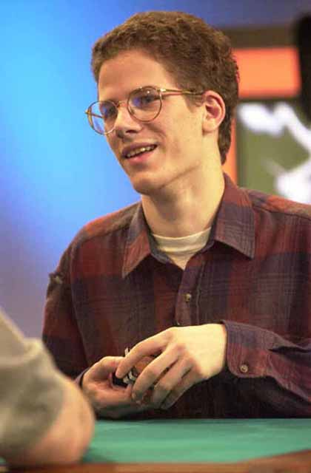
Let me tell you, that wait is a long one. With our not being allowed off stage, we have no choice but to sit there and do nothing. The newly-dubbed Elaine Chase (née Ferrao) started keeping score of our fun games while Mike lost game two. Turian and Cuneo were asked to do their mulliganing for game three while Scott and Andy J played out their Game 2. Cuneo got two Rootwater Commandos and two land, and ended up waiting an hour to see whether he'd draw the third land for the win. Scott and Andy played for what seemed like forever, and watching from afar over Scott's shoulder, I could see that once again he was not playing as aggressive a game as I would. Additionally, amid all this, he started playing to the camera, frustrating me to the point where instead of feeling impending jubilation, I got to the point where I'm searching for impending relief. Justin Gary, incredibly frustrated at watching the duel, started coming over to our table, begging for release. Finally, Scott was able to cast the Vitalizing Winds and ride in for the win.
2-0

When you've considering quitting and this kind of thing happens, you feel relief
If you look at the pictures of me on stage afterwards, you'll see that the jubilation is absent from my face. I was definitely pleased, but relief was what I felt. Not just relief at pulling out my match or the whole match, but at the knowledge that almost four years of PT play hasn't been for naught, and at the fact that the win means at least one more year at the table. When you've considering quitting and this kind of thing happens, you feel relief.
We celebrated on stage for a while and went through the trophy ceremony. I looked at the oversized check I'd held 24 hours earlier and realized that it was ours. That meant no more scraping together enough to pay for the airfare to the next PT. My bank account was flush. I did a quick photo session with Craig Cudnohufsky and then an interview with Kim Eikefet. I called home to let my mom know the good news and then I sat, relaxed and soaked in the moment. Ryan Carpenter referred to me as "a Pro Tour Champion" and then it really sunk in. Kyle Rose let me know that he wouldn't be going to the Invitational and all was good with the world.
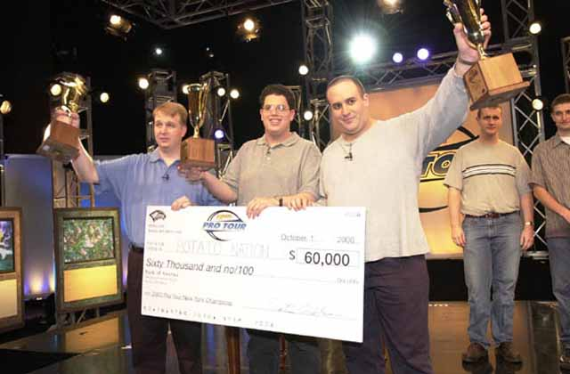
The aftermath is a bit of a whirlwind. Jeff Donais, Randy Buehler, James Lee and I went for dinner at Michael Jordan's Steak House and had a great time. Randy and I then headed to Neutral Ground where we recruited Worth Wollpert and Gab Tsang for a 4-on-4 Invasion draft against Billy Jensen, Bob Maher, Hacker and Igor. Gab was on our team instead of Hacker's because Worth refused to draft against him. When Hacker and Igor went along with the idea of Gab coming onto our team, he avenged his honor by spanking both of them. A word of advice for you team drafters out there: if you're ever going to draft a brand new set, try to get the R&D guys on your side of the table. I beat the Great One again and comforted him by saying it was just a good weekend. Finally, come 4 AM, I headed out, get packed and go home.

Epilogue
It's amazing how winning a Pro Tour can change your life. My timing was amazing if you think about it. When Your Move Games won last year, they each got $10K. I got twice that plus four Masters Series invites. Pretty good. While I was thinking for a time about quitting Magic, now I know I'll be around for a while. To those of you who like me, that'll hopefully be a good thing. To those who don't, it's probably really bad. With Magic now being a full time occupation, I've had thoughts of moving to the States so I can work with a group of more dedicated players, but for the time being, Toronto remains home. With Grand Prix Dallas and trips to Sydney and Buenos Aires on the horizon, Chicago is a light at the end of a very long tunnel. I'm completely lost with regards to building decks for the T1 and Bring your own Block formats for the Invitational, so if you have any thoughts-and if you're still reading-feel free to drop a suggestion in my mail box. This report took more hours then I can count to write, and as a result I'm behind on my work for the sideboard, but the Invasion articles will be forthcoming. I hope that 6-7 hours you've been reading now have been worth it. Let me know if it has at JgaryWise@yahoo.com.
As for Chicago, I now have a team, so the situation seems to have been solved for the time being. I received my check today and stared at it for what seems like hours. For those of you who can't understand why I would write a 40 page tourney report, I just hope you enjoyed it. For those of you who do, I hope you'll follow suit. It's our responsibility, as members of the Magic community, to keep the Magic community growing and informed. Thanks for reading.

Props and Slops
Well, no tourney report is complete without these acknowledgements. If I leave anyone out, I apologize. I've been writing for a week and a half and I'm damn tired.

PROPS
- Mike Turian - You mastered the format like no other
- For being a great friend and teammate. I am honored to have your name next to mine in the annals.
- Scott Johns - You always won when it counted
- For trying to make the best of a bad situation
- Gab Tsang - For stepping up and telling Zvi he was wrong
- Billy Jensen - Winning is great
- Jason Zila - An incredible talent. Thanks for reminding us of the past. Hope it'll lead to the future
- Ben Rubin - You played pretty damn well in our match
- Tony Dobson - One of the good guys
- Baberowski - For doing well enough on the Masters to necessitate an appearance in Chicago
- Omeed Dariani - Monty would have openly prayed for me to lose.
- Jeff Donais - Thanks for dinner
- Becky Hiebert - See "Jeff Donais"
- Hacker and Pikula - Two of the great characters in our game
- Dale Taylor - An interesting approach to the game
- Stephan Valkyser - The most consistent player in the game today
- Christian Lührs and Aaron Forsythe - Two great guys to hang with on stage
- Justin Gary and Alan Comer - Because this is one way I can tell you that these guys deserve an Invitational spot.
- Mike Stehr - For our talk after our match.
- Skaff Elias - For not letting me think it was over
- Our Lucky Judge - You know damn well why.
- Thomas Bisballe - Cheapest drunk on PT.
- Dan Grey - Firm but Fair.
- Mike Long - Surprised? For trying to name his team "Deadguy." Best laugh I had all weekend.
- James, Collin, Keith and the other judges - People don't thank you enough
- Curriscaria Plata Forma - How could I not?
- Eric Lewandowski - Otherwise known as Spambob, I owe this guy a lot of credit for my success on the Pro Tour. Eric is the creator of NetDraft, the single greatest resource for a player trying to improve their game in existence, and I continue to be its greatest advocate and spokesperson. Thank you so much for this gift to the Magic community. He did it for no other reason but his love for the game.
- Andrew Cuneo - One of the most fascinating people in Magic
- Kai - Thanks for fighting on my behalf. I won't let you down.
- Matt Vienneau - A new lease on life. I hope it works out
- Finkel - Simply a pleasure and marvel to watch.
- R&D - Invasion is great. Good job
- Auction of Champions - Best format ever
- Worlds 2001 - Party in Toronto!
- My opponents - I enjoyed all but one match
- New York City - My kind of town
- Gary Wise - After 19 Pro Tours, I think I deserve a prop.

SLOPS
- Zvi Mowshowitz and Seth Burn - you took a bad situation and made it worse by avoiding me all weekend instead of having the decency to confront me and be honest about your actions. Time to grow up boys.
- Ben Christianson - Next time, be more careful before throwing around accusations of lying.
- Curriscaria Plata Forma - God we need one in Toronto
- Andy J - Who says no to the split??? Turian's your roommate for God's sake!
- Everyone who told me that I was being screwed - You each know that in reverse situations, I would have stood up for you. Telling me how bad you feel does nothing for me. Next time, do something about it.
- Brook North - Next time, don't be a dick. If you're the only one laughing, it isn't funny.
- Mouth - You have away with words. Try using it more constructively
- Eileen Sheckler - What kind of a fan club doesn't show up?
- Hotel Pennsylvania - When you have a three-hour line up for check-ins on a constant basis, you're definitely doing something wrong.
- Brian David Marshall - READ THE BOOK
- Cheaters - You know who you are
- Gary Wise - I'm so going to get beat down at the Invitational again. Help!
- At World Championships, amidst a day of bad draws and incredible stress, I blew up at a judge who didn't deserve to have my problems unleash on him in a psychotic fit. You know who you are, and I know we'd already cleared things up, but my behavior was uncalled for and I think you deserve this public apology. I'm sorry
- For spending a week and a half writing this instead of the Invasion draft articles Thanks a lot for reading. If you got this far, you're a warrior. Hope it was worth it. I know it was for me,
Gary

*IMPORTANT*
With the first half of my report going up with only myself and my editor as the article's conscience, there have been a few points brought to my attention that should be addressed. First and foremost amongst these is that the sequence of events contained within are presented from a purely one-sided viewpoint, that being mine, and this should be considered while reflecting on them. Additionally, I don't think I fully illustrate my own behavior as a response to those events, and that behavior was admittedly less then level headed.
There are also a few important points about my former teammates that should be addressed. First off, When I say that Scott Johns did not do enough in my estimation, that is not to say that he did not do a lot. Scott went to his new list each day and suggested a reconsideration with regards to my omission, and for me to not acknowledge that would be wrong. Additionally, if it seems that the only reason Scott was our third was our Mogg Squad ties, that impression should be corrected. That Scott was willing to travel to GP's St. Louis and Pittsburgh was of importance, as Dave Price was not willing to commit 100% at that moment in time (Dave would later attend both). Additionally, I was aware of Scott's vast experience with team sealed deck, and this was a definate consideration in our decision.
As for Zvi Mowshowitz, I stand behind much of what I said, but there was something important that I forgot to say. Regardless of my personal relationship with Zvi as it stands and my feelings towards him at present, it should be noted that for his faults, Zvi is one of the most positively influential and important members of the Magic community. He spends as much time and energy writing about the game as any player on the pro tour, probably more. I wrote an article after the beginning of this whole mess about who I would vote into the Invitational if I were to do so on a completely impartial basis, and I found Zvi to be the second most deserving individual on the Pro Tour without an invite. Zvi's play, deckbuilding and community contributions should never be disregarded, and that I did so means my report was incomplete. I hope I've corrected that error.

